GFAR LOGO POLL

Thank you for participating in GFAR’s logo poll, we at the secretariat have undergone a rigorous selection process to present the following 3 options of what GFAR’s future logo could look like.

Kindly use the highlighting pen tool to mark your selection and once done email back this copy to esther.kimani@fao.org.

For reference this is what the current logo looks like

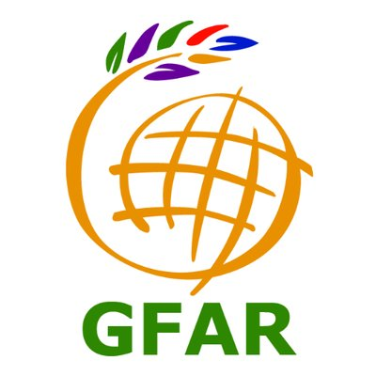

Best Regards,

GFAR Secretariat Team

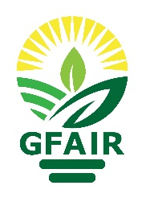
Brief: Logo in the overall shape of a bulb, landscape and a leaf showing our area of work and 13 constituents represented by the rays of the sun.
Please use the highlight tool to show your responses below
A) By how much do you feel it represents and identifies GFAR and its constituencies?
1 | 2 | 3 | 4 | 5
1.Not Much
2. A little
3. Average
4. A lot
5.Very Much
B) In your opinion, how aesthetically pleasing is it?
1 | 2 | 3 | 4 | 5
1.Not at all
2. A little
3. Average
4. A lot
5. Very Much
C) How much do you feel it keeps up with modern times?
1 | 2 | 3 | 4 | 5
1.Not at all
2. A little
3. Average
4. A lot
5. Very Much
D) How much do you feel this logo will identify GFAR (By looking at it immediately associate with GFAR and the work we do)
1 | 2 | 3 | 4 | 5
1.Not at all
2. A little
3. Average
4. A lot
Comments

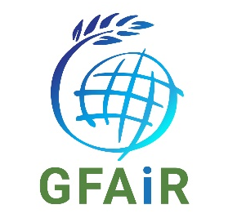
Brief: Remade ‘old’ GFAR logo with play on colour and the addition of the ‘I’ for innovation
Please use the highlight tool to show your responses below
A) By how much do you feel it represents and identifies GFAR and its constituencies?
1 | 2 | 3 | 4 | 5
1.Not Much
2. A little
3. Average
4. A lot
5.Very Much
B) In your opinion, how aesthetically pleasing is it?
1 | 2 | 3 | 4 | 5
1.Not at all
2. A little
3. Average
4. A lot
5. Very Much
C) How much do you feel it keeps up with modern times?
1 | 2 | 3 | 4 | 5
1.Not at all
2. A little
3. Average
4. A lot
5. Very Much
D) How much do you feel this logo will identify GFAR (By looking at it immediately associate with GFAR and the work we do)
1 | 2 | 3 | 4 | 5
1.Not at all
2. A little
3. Average
4. A lot
Comments

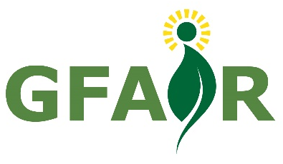
Brief: Word GFAIR with the ‘I’ having a leaf and 13 constituencies represented
Please use the highlight tool to show your responses below
A) By how much do you feel it represents and identifies GFAR and its constituencies?
1 | 2 | 3 | 4 | 5
1.Not Much
2. A little
3. Average
4. A lot
5.Very Much
B) In your opinion, how aesthetically pleasing is it?
1 | 2 | 3 | 4 | 5
1.Not at all
2. A little
3. Average
4. A lot
5. Very Much
C) How much do you feel it keeps up with modern times?
1 | 2 | 3 | 4 | 5
1.Not at all
2. A little
3. Average
4. A lot
5. Very Much
D) How much do you feel this logo will identify GFAR (By looking at it immediately associate with GFAR and the work we do)
1 | 2 | 3 | 4 | 5
1.Not at all
2. A little
3. Average
4. A lot
Comments

